In the Dunes

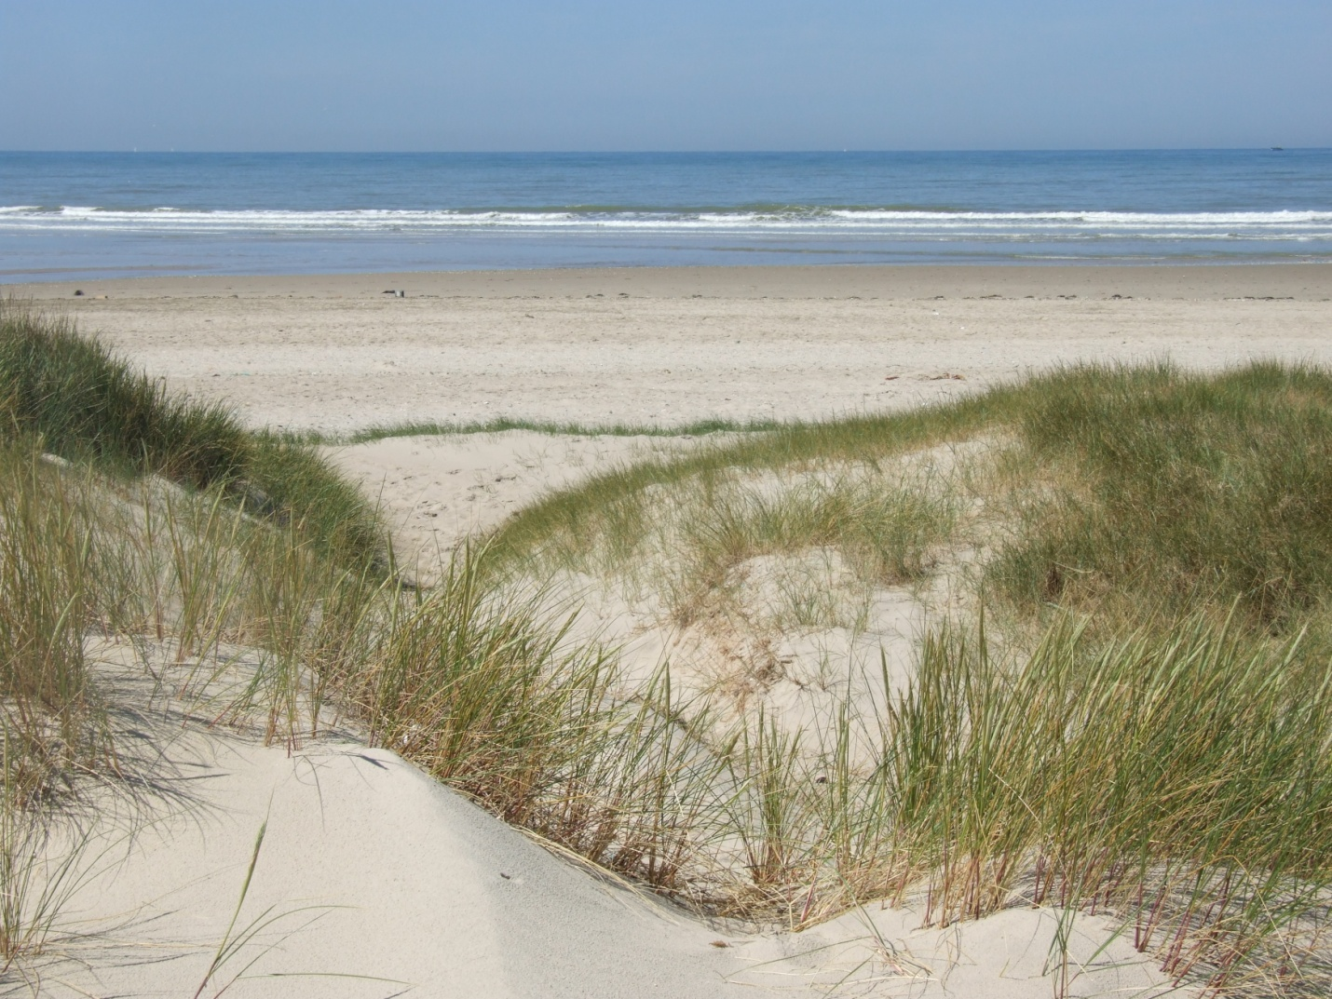

by Jim Sweetman

It had been a busy day at work and, at one time, she thought she might even have to stay late but then Janet said she was going to do another couple of hours so she was free to go. She was pleased. It was a warm summer evening and the air was inviting so as soon as she left work she knew she was going to nip home, get changed and make her way down to the coast for some late evening sun and whatever else. She left her tights behind, slipped on her sandals, grabbed a bag with her towel in, picked up her book, a bar of chocolate and a water bottle and she was on her way. It felt good. There was no one at home to miss her, she could ring her mother later and it wasn't much fun at the library today. First thing, there was an argument over the Internet terminals and a bit of queue jumping and then a party of primary school children came in and simply grabbed books off the shelves. When she asked one of them to be more careful she got a grunted reply but then she could hear his friends imitating her voice and her polite request. She was glad when they all left but then, of course, all the books had to go back in the right places. It took a while.

But now she was here and pulling into the car park. In a few weeks in high summer it would be crowded with holidaymakers but now, and at this time of day, it was quiet. It never got really busy because the holidaymakers with families who wanted to get to the beach as quickly as possible did not want to walk across the dunes and there were notices to discourage them and a tatty fence between the dunes and the sea all done in the name of avoiding coastal erosion. She didn't mind because she wasn't here for the sea and the beach, just a sun trap in the dunes. There was just one car pulling out of the car park. The driver stopped and waved for her to go in first. Woman driver, she thought, always more considerate and the woman smiled at her and mouthed a friendly hello. She seemed a bit familiar, not glamorous, mousey hair. Maybe she was a member of the library.

Come to think of it, the only people she ever seemed to see here were single women or, at least, women on their own. Of course, if you had a family this would be the worst time to get away and read your book and you'd be cooking dinner and waiting for your husband to come home so it probably wasn't that surprising. She wondered how many women found solace here in this sandy oasis.

And she also knew that women were more likely to recommend a nice place to other women. In fact, it had been her friend Sarah who first suggested this was a good place to relax and insinuated that she'd been looking a little bit stressed and it might help her to unwind. Sarah was married now and she didn't see so much of her but it was good advice and kindly meant. She wondered what Sarah had known back then.

She walked up through the dunes slipping off her sandals and feeling the sand beneath her toes. She loved the warmth and the graininess and the way the sand trickled and gave beneath her heels. She stood for a moment and simply enjoyed the sun, the distant rolling of the sea and the calls of the seabirds. It was a short climb along a sandy pathway into the dune and the paths diverged and then joined again intermingled with patchy tufts of grass and sandy hollows. There were so many ways to go you were less likely to meet anyone but she saw someone ahead coming towards her. It was another woman, an older one, carrying an anorak over her arm and cheerfully walking. She stopped to let her pass.

‘It's so good up here,’ said the woman, ‘you can taste the air.’

She smiled, thinking that was a slightly strange comment but then the woman half turned and spoke again. ‘He’s here,’ was all she said. ‘Just wait and watch.’ Then the woman was gone almost bounding down the pathway and quickly out of sight.

She was secretly pleased to be alone again. This was her space and, now, she was on top of the dunes and it was easy to find the favourite hollow where the sand had built up the sides and the back but the front was open to the lowering sun. There wasn't much breeze today but this was always a perfect trap for the remaining sun and its heat.

She spread the towel so she was on a slight slope facing towards the sea, used her bag to create a pillow, had a sip of her water and found a comfy reclining position on her back where she could be supported by the sand behind her and her bag as she read. Now she could enjoy the sun, already warming her bare legs and she wiggled her toes in the sand at the pleasurable sensation it gave her and read her book.

A few pages on and she paused reading. She was feeling tired in the warmth and the silence and not really concentrating on the plot which was increasingly convoluted. She was trying to remember who everyone was while years whizzed by and not much happened and then cousins arrived who were related to someone who passed through quickly forty pages earlier and they didn’t do a lot either. She could feel her eyelids suddenly quite heavy so she put the book down spine upward to keep her place and lay back feeling the sun and the warmth on her body. She drifted.

She wasn’t sure she had slept and, if at all, only for a moment but she was suddenly awake. There was someone else in the dunes, coming up the slope from the seashore, singing quietly to themselves thinking that they were as alone as she was. Her instinct was to feign sleep, whoever it was would see her and leave politely and she could get back to her book but she also made sure she could see through her almost closed eyelids as a figure came out from one of the tracks in the dunes. She kept quiet.

It was a man. He had clearly been swimming and was shaking the water off him like a dog while rummaging in a plastic bag and pulling out a towel. She could see that he was quite tall and, well, fit there was no other easy word for it and she could see the muscles in his torso move as he stretched the towel behind his shoulders and rubbed. She could have completely shut her eyes. She didn’t although he seemed quite unaware of her presence.

He was wearing blue swimming shorts which she noticed while carefully not peeping and his chest was covered with wet, dark hair as were his long and lean legs. Having dried his back he now started to rub the towel across his chest with long slow deliberate moves. Suddenly, she was conscious of her bare legs and a warm flush suffusing through her body and then she saw him ease off his swimming shorts and kick them to one side and the warmness was suddenly a rush of heat.

He still seemed unaware of her although he could only have been three metres away from her and, now, he was towelling his thighs and drying himself between the legs. She could see all of him. Then he turned towards the sea and she could see from the back. At least she couldn’t be seen this way as he continued to dry himself allowing the sun as well as the towel to do the work.

She was undoubtedly excited by this man and the sight of him although she would possibly have denied it and it must have been something unconscious or a need to adjust herself to be more comfortable that made her lift her knees slightly and part her legs. She was conscious that her knee length skirt might be riding up and was about to reach down and smooth it when he turned around again. She froze instead but she thought he had noticed the movement.

There was nothing to be done but admit her presence. She stretched as if awaking from sleep with a slightly exaggerated stifled yawn, stretching her arms out then back across her face and stretching her legs as well. She also half opened her eyes.

‘Sorry,’ he said, ‘I didn’t know anyone was here.’ He was holding his towel bunched to cover himself.

‘It’s okay,’ she said, ‘I must have fallen asleep. It’s quiet here.’

He was looking at her, quite intently. ‘I won’t be long,’ he answered but she knew that he could see her uncovered knees, the bare thighs - maybe even more.

‘It’s all right,’ she said but she really couldn’t stop herself. The thought of him looking at her, the hardness of his body, the glimpse of him was like an electric charge and she allowed her legs to part further, the skirt to be more abandoned. She wanted him to see. She ached to be touched and, at the same time, she realised how long it was since anyone had made her feel like that and she slid her hand down her body to lift the hem of her skirt and then to touch herself through her pale pink underwear as she watched the towel drop away from his body revealing a heavy swinging cock as evidently aroused as she felt her body to be.

He came towards her almost standing over her and she raised her hand to beckon him closer until her fingers reached him and she closed her hand around his shaft feeling the weight and the hardness. Then, he knelt in the sand and his hand was on her thigh, higher and slipping under the edge of the panties and then she felt his fingers probing. She was so wet. She couldn’t stop, tipped over a shuddering edge, so in need and hot.

‘Turn over,’ he said. His voice was soft but insistent. She had to stop stroking and squeezing but she did as he said and then she was face down with her head in the towel and the soft sand. She felt him ease her panties down and moved her knee to help him and then he was behind her and she braced as he pushed into her. It was hard and fast, he thrust into her deep and desperate and then out and then plunging again and she felt herself sighing and breathing hard with each push. She felt so wet, she couldn’t stop. It felt so good, so hard, opening her wider with each thrust. She came again as he did, pumping hotly on the crack of her bottom as he pulled out of her so that she felt the spurt of him. Then, she was stretched out flat with him on top of her suddenly still and she could hear the seabirds on the beach.

‘Thank you,’ he said and then lifted away from her and must have stood. She sighed with pleasure then turned to speak to him but he was gone and there was no-one in this enclave in the dunes but her. She got to her feet, slowly and not a little unsteady. No-one there. She walked to the edge, looked out over the beach. No-one there either, it was empty. The man had simply disappeared. Her panties were in the sand and she shook them out before putting them over her ankles then reaching into her bag for a tissue to wipe herself. It was easier than she expected, there was no evidence of their lovemaking on her body. Then, she packed her small bag and walked back down to the car with a slow smile on her face. Another small car had just pulled in and parked and a youngish woman was getting out of it.

‘Lovely evening,’ the woman said as she started to walk up the path. ‘I’m a bit late for the sun.’

‘No worries,’ she said with a smile. Then, she added without thinking, ‘he’s here.’

The younger woman stopped suddenly and looked at her. ‘You too?’ She asked.

‘Yes,’ she replied, ‘enjoy it.’ She smiled as she drove back to the city.