The Bay

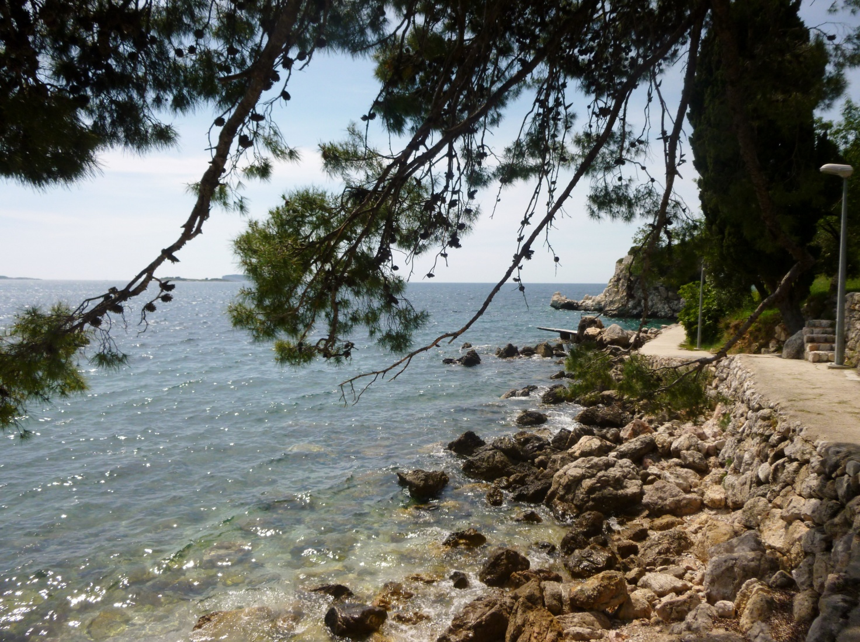

Jim Sweetman

It had been a few days previously when Gracie first found the bay, her beach with the tiny strip of sand, the draped palm trees and the flat black rocks running down into the sea. It was around a twenty minute walk from the resort, the first part easy along a well worn track and then the land rose and the path picked its way through rocks and gorse going higher to discourage the casual walkers before falling quite steeply down to the tiny bay and the beach. She hadn't seen anyone here before although the occasional yacht pulled into the bay and spilled raucous holidaymakers into the sea but they kept away from this part of the beach and were soon sailing away to sleep off their drinks and fun in the heat of the afternoon.

That was the time that Gracie liked best when the air was so hot it shimmered and the trees were still and the waves barely summoned up the energy to lap the stony shore. She liked to sit away from the sun in the shade of the trees perched against a rock, her knees drawn up and lost in her book, still and quiet. It was a magic place, hot and perfumed from the sappy trees and shrubs, apart from the bustling world of the resort and almost hard to breathe because of the headiness of the air, thick and warm.

So, the man appeared as an interloper interrupting her peace and her private place. One minute he wasn't there and the next he was. She never heard him arrive. He had found his way to one of the large flat rocks just in the corner of her view and she could just see him stretched out on its flat blackness through the hanging greenery and the bushes. Although he was close, she couldn't see much of him but she was aware that he was there, in her private place. Of course, he was entitled to be here just as she was and yet she could not help feeling that she wanted to preserve her solitude. It was a silly thought but it took her concentration away from the pages in front of her. The story was slow moving and the heroine had failed to take one intelligent decision in the last hundred pages, lurching instead from crisis to crisis. When she met the right man she said the wrong things and the wrong man misread her signals and thought her clumsy attempts to be friendly were some kind of invitation. Then the right man saw her with the wrong man and thought she was the wrong girl. There was a lot of anguish. Gracie was bored.

She looked round and noticed that the man on the rock was still there. She could see his bare feet and the vague leafy outline of the rest of him but it was enough to show that having been unmoving since his arrival he was not still now. He was moving and there was the print of his motion written on the leaves. Gracie shifted a little to her right and slightly forward. She moved quietly keeping herself hunched and moving on her haunches across the grass to the shelter of another rock.

From here, she could see more of the man and what he was doing. She first noticed that he was naked except for what was probably his t-shirt draped casually over the lower part of his body just below his navel. He was tanned, his hair short, wearing aviator sunglasses, a fuzz of dark hair over his chest, skin shiny with sweat. His hand rested casually across his body where his dark brown t-shirt was. He was alone.

Gracie was unsure of what to do next. Backing herself to the safety of the original rock would be more complicated. Although she felt her thoughts beginning to whirr, she knew that the best thing to do was to return to her book. The man was entitled to his bit of rock and sunshine. He would not disturb her.

Her book was also going nowhere at that moment. The wrong man was making clumsy advances to the right woman and she had got herself into the wrong place at the wrong time and his kisses were getting, suddenly, a little out of hand and she was embarrassed but didn't know what do next.

She's stupid, thought Gracie and then thought of her own place and predicament which was stupid too and then she looked away from her book towards the man on the rock. It took a double take to see what he was doing. She looked, then looked abruptly away and then looked back. Yes, there was no doubt. His hand was now under the t-shirt and moving and the fabric of the shirt was draped oddly over his hand and what was obviously his aroused body.

Gracie was not narrow minded or a prude. It was simply one of those accidents of life and circumstance that had contrived to make her life so cloistered recently. The break up with Marty had been painful and acrimonious and although it was almost a year ago it had put her off sex and men. Life itself had seemed to have taken on a dull monochrome sheen. She went to work, she came home. She saw friends and had slightly distant conversations where they avoided talking about the things that were most important to them in case she would be upset. They also avoided talking about Marty who was still part of their larger circle and that left things unfinished in unsatisfactory ways. In between, she ate and drank rather less and more than before and without much enthusiasm.

The odd attempts to conjure up some excitement, once with an old flame and once with a new acquaintance had not been a success. Both left Gracie feeling slightly soiled and used, feeling that she had expended a lot of effort for little return. So now she realised that she had not even seen a man naked for the best part of a year and, maybe, it was that and maybe just curiosity that kept her watching. There was a hint of what she used to feel, of sensations that had been long buried and their return was unexpected.

If there had ever been any doubt, it was now clear what the man on the rock was doing. The t-shirt had given up any attempt at modesty and the man was now working his hard cock, his hand along the shaft, shaking and stretching. Gracie watched, peering over the top of her book, fascinated and not a little excited. She could hear him now, breathing heavily with each tugging motion and then moving faster, his thighs flexing and straining. Sometimes he slowed as if thinking about something and then moved again faster. Sometimes he seemed to be listening, perhaps making certain that he was alone. Gracie kept still although inside she felt herself squirming watching the heavy cock in his hands at first still and then starting to move again.

Then he began to move faster again working his hand up and down, the shaft bobbing with it, the tip hard and red until with an audible groan he came, spurting gobbets of semen upwards and then onto his stomach. After a pause and perhaps a little more aware of where he was, he rolled over onto his side almost facing her then wiping himself with his t-shirt over his stomach, fuzz of hair, the semi-tumescent cock, then squeezing out some last drops and wiping again.

It was just as he made the last move that Gracie knew he had seen her. No more than fifteen feet away she would appear head down in a book, her knees drawn up. There was no indication that she had done anything else or been there for any time or that she, herself, had seen him. However, he might be able to see that the book cover was, without reasonable doubt, upside down. He might also take in her slim build, shoulder length light brown hair and a tanned body, thighs and legs under her hunched knees and a yellow bikini.

The safest thing to do was to dismiss him from her thoughts. If she didn't see him then etiquette would suggest that he should do the same. She sensed that he was finding his shorts and would try casually to ease them over his feet but knowing it would look like a performance whatever he tried. Then, looking in any direction but hers, observing the bay a little too closely as if something utterly fascinating had just surfaced there he would be on his feet and gone, backing onto and up the path.

Gracie breathed out as she heard a movement. He was gone. She hadn't realised how she was holding her breath, that her eyes were closed and when she opened them she saw the lines of text all upside down. At least he didn't see me, was her thought as, soon after, she retraced her steps along the path to the resort but, later, when she was in the shower her thoughts wandered back to the bay and the beach. It was her bay, she thought, but she also thought about how hard it was and the noise he made and she rubbed herself down with the sandpapery hotel towel with extra ferocity to punish herself.

The next morning she was persuaded to visit some local caves and the trip turned out of course to involve a line of small shops selling tourist tat plus an overpriced and none to clean restaurant for lunch. To console herself she ordered a large glass of wine at an absurd price. She was glad to get back. She hadn't planned to go back to the bay but the beach was full and noisy. The best deck chairs and sun beds were gone and music was blaring from somewhere so she continued to walk and soon she was back on the familiar path ascending through the scrub.

She almost walked into him. He was coming along another path which met the one she was on. She knew it was him intuitively, although she would have known him by his build as well and the thick black hair.

'Sorry,' he said raising his arms in apology. 'There aren't many people in this part of the bay. I hope I didn't startle you.' He spoke in confident English but was clearly foreign, his accent impossible to place, maybe slightly Scandinavian or German.

'No, not at all,' she replied. 'It's fine.'

'Are you going down to the bay?' He asked. 'It's great down there,' as he evidently feigned non recognition and tried to chat.

'Yes,' she said, 'it's lovely and quiet. So much nicer than the hotel.' She knew that he would notice her hair. He must know. They were both walking down the track now. He was behind her. He would recognise her thighs.

'Have you been here before?' she asked brightly into space. Privately, she thought that it was a clever question.

'Yes,' he answered, 'I was here yesterday. I have often been here.'

'So was I,' she said, 'but I didn't see anyone else.' She knew she said that like a criminal absenting herself from the scene of the crime before being asked if she was ever there.

They were at the bay now where the path widened out slightly, facing each other a little awkwardly.

'Sun or shade?' he asked.

'I'm a sun lover,' she said, 'but my skin doesn't allow me too much of it. I have to be careful.'

'I love the sun,' he said, 'I feel the cold. Great time to sunbathe.'

They were down near the rock now. 'This is an ideal place,' he said, 'the rocks keep the heat of the sun. You can bake!'

'Go for it,' she said. 'I'll just sit back here a bit in the shade.'

She watched him step out onto the rock as she sat down. He was only wearing shorts. Yesterday she had been to one side of him but today she was looking down from a position close to his head as he rolled over onto his front and rested his face on his arms so that he was looking at her. She could see the length of his back and the baggy, military style shorts. His feet were bare.

'This is nice,' he said.

'Yes,' she replied, 'lovely.'

'All this nice sun to stretch out in. Aren't you hot like that?'

Gracie was aware she was slightly overdressed. She was wearing her shorts over her bikini and a halter top.

'No, I'm okay,' she said. Truthfully, she was feeling hot, and slightly hot and bothered too.

'You need your bikini. Put it on. I'll shut my eyes.' He laughed.

'It's all right I'm wearing it,' she said. 'it's a little cooler here in the shade,' she lied,

'Is it that nice yellow one again?' he asked.

Gracie flushed from head to foot. She felt minute drops of sweat bursting out all over her body. She realised that he had seen her yesterday. It was obvious when she thought about it. She cursed herself inwardly for not having her book with her today. She would have liked something to bury herself in. She managed to nod her head like some guilty schoolgirl.

'Did you see me yesterday?' she asked trying to make her voice sound normal. 'I was deep in my book.'

'The one you were reading upside down?'

'What? No. Maybe the cover was the wrong way up?' Gracie was flustered.

'It's okay,' he said. 'I'm just joking but you can wear it anyway. Go on, there's nobody here.'

It seemed easier for Gracie to agree rather than engage in further discussion about yesterday so she unfastened her halter top. Then she was conscious of her breasts in the bikini top. She had always thought they were too big and now they seemed to be spilling themselves shamelessly out of the cups of the bikini. She was glad to be able to take off the shorts almost as a distraction. She folded them and sat on them.

'Better?' he asked.

'Yes,' she replied, leaning back and conscious of his continued gaze which seemed to linger for a moment on her breasts and then move languidly down to her thighs.

'I liked this sun,' he said. 'I thought I was completely alone here yesterday. I had no idea anyone else was nearby.'

'I'm not surprised, it's really quiet.'

'And then I looked up and saw you.'

'Did you? Where was I? I didn't see anything.' Gracie was conscious that she was protesting too much.

'Just by that rock over there. I think that you might have moved there while I was sunbathing.'

'Me, no, I think I was in the same place just reading my book quietly.' Gracie knew she was blushing.

'You weren't watching then? You didn't see what I was doing?'

'No, nothing, I've been reading a really good book!'

'The one you read upside down?'

'I don't know why it looked like that.'

'Maybe because you weren't reading it? Maybe because you moved there to see what I was doing?'

'No, I wouldn't do that.'

'Wouldn't do what?'

'Move places to watch someone. This is a very private place. You can do what you like here.'

'Like what?'

'Well, anything.'

'And you wouldn't move places to watch then?'

'Not me, never. I was deep in my book.'

She caught his eye. He was looking at her. She knew he could tell.

'Even if I saw something by accident,' she said, 'I'd forget it.' Gracie had the sense that she was getting herself into some kind of knot.

'Like someone sunbathing without any clothes on?'

'Yes, anything like that.'

'So, did you see me?'

'I suppose I might have done,' she said, 'but I wouldn't have given it much notice. It's a free country you can do what you like.'

'That's true,' he answered. There was a pause as he stretched out.

'So, if I had seen you do anything I wouldn't have mentioned it.' She emphasised the 'had'.

'Anything?'

'Well you know what I mean.'

'Not exactly.' Gracie found herself increasingly drawn into this conversation which she wasn't sure that she wanted to have.

'So you might have moved in order to see what I was doing?'

'I might but I didn't.'

'And you might have seen something you didn't expect?'

'Well, yes, if anything had happened.' Gracie didn't get the impression that he was playing with her. It was a more a simple unravelling of events. She also found herself remembering more vividly what she had seen yesterday. The size of it, the way it stood up in his hand, the energy in his wrists. The thought made her more self aware of her pose and his gaze.

'It makes us not quite even then,' he said.

Gracie lost the point. 'What do you mean?'

'Whatever you saw me do.'

'So?'

'Maybe you should do it too. Then we're even.' He smiled.

Gracie tried to laugh. 'I wouldn't know where to begin,' she said, 'as I'm not sure what you're talking about.'

'Try and remember,' he said.

She didn't reply.

'I think your breasts might remember,' he said, 'a certain feeling of them filling up, a heaviness in the nipples, a hotness.'

'Don't,' she said, 'but she did remember exactly that and how it felt.'

'Maybe you want to touch them?' he said. 'Cup one of them in your hand, feel the tip against your palm. Feel that slight hardening.'

'Stop it,' she said, 'don't be silly.'

'You know you want to touch. There's no use pretending.'

He was right. Gracie did want to touch her breast, right there. The nipple was simply aching to be caressed and squeezed.

'Do it,' he said. 'Slide your hand inside and feel it.'

'I'll touch the outside,' she said, as if it was a compromise.

'Now, then, do it.'

And she did it. Gracie slipped her hand over the cup of her bikini top and then inside it, cupping the breasts.

'Rub it,' he said. 'remember what you saw me doing. Rub and squeeze.'

This is stupid, thought Gracie but her fingers thought differently and were happy to obey. She liked the feeling.

'You like me to watch?' he asked.

'No, yes, I don't know. Please yourself,' she answered, then felt sorry because she did not want to appear to be rude. She realised that she liked this man and that she was aroused by his gaze. She also felt perfectly safe. On the rock he was too far away to touch or be touched but he was watching intently.

'Now, lower,' he said, 'stroke between your thighs.'

'No, I can't,' she said.

'I think you can. You watched me yesterday, now I can watch too.'

Gracie suddenly realised that she was more in control of this meeting than she knew. The man's wish to watch and his idea that he was somehow entitled to - after the events of the previous day - was nonsense but, at the same time, Gracie enjoyed his frankness. There was no threat. The man had made no attempt to touch her and in the bright light of the sun and stretched out as he was he seemed somehow further away. She also knew that she wanted, really wanted to do as he asked.

Since the break up, it was as if her body had closed down below the waist. Everything was there, the controls were in good working order but there was no driver. When she attempted to arouse herself it was a long slow process and hard work to reach an unsatisfactory climax. Sometimes she was half way there and the feelings faded and it was easier to make a cup of tea. The two brief liaisons in the past months had foundered because she felt like that. She had the sense of standing outside her body while a near stranger played with it, rubbed and poked but never in quite the right places. There was no passion.

Here, she felt different. Her body felt electric, her clitoris demanding to be touched as she felt herself plumping and pulsing with arousal. Her hand simply followed her desire down between her thighs to where she felt so hot and wet. She touched and then wanted more and she slipped her finger under the edge of the bikini and slowly eased it across so that she could be seen, let her thighs fall slightly further apart and then began to touch herself right on the spot of her arousal.

She wondered if he would start to do what he had done yesterday but instead he continued to watch her.

'Let me hear you,' he said.

Gracie was not inclined to be noisy during sex and her orgasms were more clenched and strained than she cared to admit to herself. So, the low moan that came out now even surprised her. It was a long sexy moan, half sigh, half lust and almost animal and as it escaped she slipped a finger into her wet, hot and slippery cleft and realised that there was no doubt. She was going to come, unavoidably and soon.

She squirmed on her shorts and adjusted her position slightly so that, if she was honest, more of her could be seen and she could slide more of her finger inside. She moaned again as she did this and then ran her wet finger back up to her swollen clitoris rotating it on the spot, circular motions sometimes hard sometimes soft.

Then she felt it building, her thighs were tight, her body almost ready to explode and she looked at him and their eyes met and then she felt the first shudder and then another and then the first fast throbbing of her orgasm. 'Yes, yes, fuck me,' she mouthed and then it went on, and on, shaking away the cobwebs of the last year as she came with a final shudder and moan.

The man who had watched and listened now put his head down on his forearms and gave a long heaving sigh, clearly overcome in some way. For a moment, Gracie thought he was crying and perhaps he was. The moment of not being observed allowed her to let her bikini fall back into place as she leant back against the rock, her heart still beating quickly feeling the warm glow permeating her body, and a sensation that she seemed to have lost for so long.

Then he looked up again. 'Was that what you wanted?' she asked.

'Yes,' he said, 'thank you. So exactly right. You have no idea how good that was for me.'

'And for me,' said Gracie a little cheekily.

'I must go now,' he said. 'It is hard to stay but thank you,' and he stood up, turned away from her and then dived from the rock into the sea. There was no splash. He was simply gone.

Gracie was surprised but only momentarily. It was easy to see that he might have been embarrassed and decided to swim around to the next bay or even back to the resort. She was also slightly relieved at having the chance to compose herself in private and to reflect on what she had done. It was not at all in character but as she walked back to the resort there was a new spring in her step and a smile on her face.

The beach looked more welcoming than before. The sand was hot and the sky a deep blue and although it was still busy there were plenty of spare sun beds and the music was quieter. She picked one almost at the end of a row, the mattress was soft, she was tired from her walk and with barely time to think or to pay the attendant she fell quickly asleep.

She must have slept for an hour or so but she woke feeling rested and warmed. The sun was beginning to go down and she went down to the sea to wake herself up and to clear her head. Earlier seemed almost like a dream. Had she really done that? She smiled again at the thought of it and felt her body respond in the surf. Yes, she had.

Coming back up the beach to the sunbed, she saw a man sitting on the next bed drinking the local beer. He looked up as she came closer and smiled. She smiled back.

'Would you like one of these?' he asked gesturing with the beer bottle. 'They're very good.'

'I'd love one,' she said and he called over to the attendant.

'You were asleep for a long time. Nice dreams?'

'I think I was really tired,' she answered, 'but I'm awake now.'

'Have you been here long?' he asked.

'Five days,' she said and then the beer arrived and the conversation continued and Gracie found herself warming to it, talking about the resort and the bay and the people and, little by little, letting it slip that she was on her own and so was he. And then later, they walked back up to the hotel together and it was easy to agree to meet later in the bar and then to have dinner, and Gracie surprised herself again by accepting the offer of coffee and then kisses on his balcony.

Gracie never slept with anyone on a first date, thought holiday romances were suspect and considered herself to be the type of person who liked to take their time to get to know people but she found herself sitting astride Geoff and pushing up and down, groaning with delight until she came not once but twice and then she lay all night in his bed and did it again in the morning.

'I would like you to know I am not all that sort of person,' she said to him over breakfast and she smiled at Geoff and they spent the morning on the beach. Somewhere around mid-morning, Gracie thought about the previous day and the man on the beach. Would he be there today? Perhaps waiting for her? She felt she almost wanted to go to thank him for helping her to find herself and to draw her back from the dark place she had been in.

It was over lunch when she and Geoff got talking to another couple or rather found themselves talked to by a husband and wife who had been here, it transpired every year for five years - same hotel, same week. They knew the owner, who they appeared to be on first name terms with, as well as his extended family and they knew all of the local history and the events of the civil war which had torn this area apart only two decades before. There was still the evidence in the area with ruined buildings and neglected areas, the product of forced repatriations and post war legal wrangling. There were bullet holes in a wall which they were reliably informed was the scene of a bloody skirmish and it was whispered how some local people were rounded up and threatened.

Gracie was losing interest in these stories and looking across the table at Geoff whose eyes she could see were not only a fascinating shade of brown but were also beginning to glaze over when something was said that caught her attention. The wife was talking about a bay and Gracie quickly realised that it was her bay and she began to listen.

'It has been left as it was,' said the woman, 'for all these years.' She went on to say how the local people never went there since the war because 'something bad' happened.

'What was it?' asked Gracie.

'The government soldiers came looking for a spy and the people, frightened for their own lives, betrayed him. Whether or not this man was actually a spy or who he was working for was not clear. The government was afraid of foreigners and saw spies and double agents everywhere. He was taken down to the bay and murdered.'

'That's awful.'

'The people of the village never talk about it. They and the government soldiers were equally to blame.'

So that was it, thought Gracie. An unsolved and unreported war crime many years ago but still leaving a scar in the community like the bullet holes in the wall. An unknown soldier or perhaps simply a traveller in the wrong place at the the wrong time and one death among thousands unreported and unacknowledged and now the bay was haunted by his presence.

'That's why no-one goes there and they don't mention it at the resort.'

'I've been there,' said Gracie. 'I liked it.'

'Didn't you find it spooky? The locals say it is hard to breathe down there in the heat of the day.'

'Not at all,' answered Gracie, 'after all this time it can't still be haunted.'

'Haunted,' said the woman. 'Funny you say that as, yes, his ghost is supposed to be there. I hope you didn't meet him.'

'Perhaps, I did,' said Gracie and they all laughed around the table. Later, in bed with Geoff after another passionate session he asked her about the bay.

'Did you see anyone there?' he asked.

'No,' she said, with a smile, 'but I expect he saw me.'